/* insert in candidate table */

INSERT INTO Candidate (CandidateId, CFName, CLName, CPhone,CEmail, CStreetNo,

CStreetName, CCity, CState, CZip, CExperience, CRelevantExp)

VALUES (6, 'Robinson', 'Curt', '315-555-6666','crobinson@gmail.com', '12', 'Ostrom Ave', 'Los

Angeles', 'CA', '90205', 'Database, Business Analysis', 'Business Analysis')

INSERT INTO Candidate (CandidateId, CFName, CLName, CPhone, CEmail, CStreetNo,

CStreetName, CCity, CState, CZip, CExperience, CRelevantExp)

VALUES (7, 'Austin','Byron', '805-280-2018','abyron@gmail.com', '54', 'Skyline Blvd',

'Oakland', 'CA', '94620', 'Consultant, Developer', 'Consultant')

INSERT INTO Candidate (CandidateId, CFName, CLName, CPhone,CEmail, CStreetNo,

CStreetName, CCity, CState, CZip, CExperience, CRelevantExp)

VALUES (8, 'Tin', 'Chung', '315-685-8898','tchung@gmail.com', '69', 'Comstock Ave', 'Paperwork

City', 'CA', '94645', 'Developer, Business Analysis', 'Developer')

INSERT INTO Candidate (CandidateId, CFName, CLName, CPhone,CEmail, CStreetNo,

CStreetName, CCity, CState, CZip, CExperience, CRelevantExp)

VALUES (9, 'Cassandra', 'Alvarado', '315-555-8888','calvarado@gmail.com', '1348', 'Elm St.',

'Denver', 'CO', '80012', 'Database, Business Analysis', 'Database')

INSERT INTO Candidate (CandidateId, CFName, CLName, CPhone,CEmail, CStreetNo,

CStreetName, CCity, CState, CZip, CExperience, CRelevantExp)

VALUES (10, 'Beverly', 'Baker', '315-556-9999','bbaker@gmail.com', '4387', 'College Drive',

'Dayton', 'OH', '45404', 'Database, Business Analysis, Developer, Analyst',

'Database')

select * from candidate

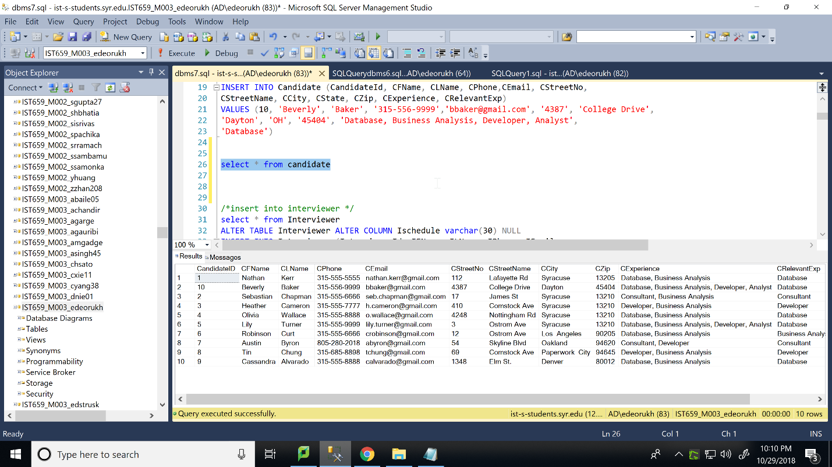

/*insert into interviewer */

ALTER TABLE Interviewer ALTER COLUMN Ischedule varchar(30) NULL

INSERT INTO Interviewer (InterviewerId, IFName, ILName, IPhone, IEmail,

IStreetNo, IStreetame, ICity, IState, IZip, ISchedule)

VALUES (6, 'Toshiro', 'Yamada', '315-666-2584', 'toshiroyamada@syr.edu',

'137', 'Geary Blvd.', 'San Francisco', 'CA', '94111', '9am-5pm Monday –

Friday')

INSERT INTO Interviewer (InterviewerId, IFName, ILName, IPhone, IEmail,

IStreetNo, IStreetame, ICity, IState, IZip)

VALUES (7, 'Gerald', 'Bernstein', '315-777-1115',

'gearaldbernstein@syr.edu', '717', 'Wilshire Blvd.', 'Los Angeles', 'CA',

'90048')

INSERT INTO Interviewer (InterviewerId, IFName, ILName, IPhone, IEmail,

IStreetNo, IStreetame, ICity, IState, IZip, ISchedule)

VALUES (8, 'Rose','Barbara', '315-888-8881', 'rosebarbara@syr.edu', '957',

'Wilshire Blvd.', 'Los Angeles', 'CA', '90048', '8am-6pm Monday – Saturday')

INSERT INTO Interviewer (InterviewerId, IFName, ILName, IPhone, IEmail,

IStreetNo, IStreetame, ICity, IState, IZip)

VALUES (9, 'Steven', 'Bernstein', '315-999-9991', 'stevenbernstein@syr.edu',

'5152', 'Rural Route 12', 'Searchlight', 'NV', '89046')

INSERT INTO Interviewer (InterviewerId, IFName, ILName, IPhone, IEmail,

IStreetNo, IStreetame, ICity, IState, IZip, ISchedule)

VALUES (10, 'Shawn', 'Micheal', '315-101-1010', 'shawnmicheal@syr.edu',

'258', '1st St. NE', 'St. Paul', 'MN', '55111', '9:30am-5:30pm Monday –

Friday')

select * from Interviewer

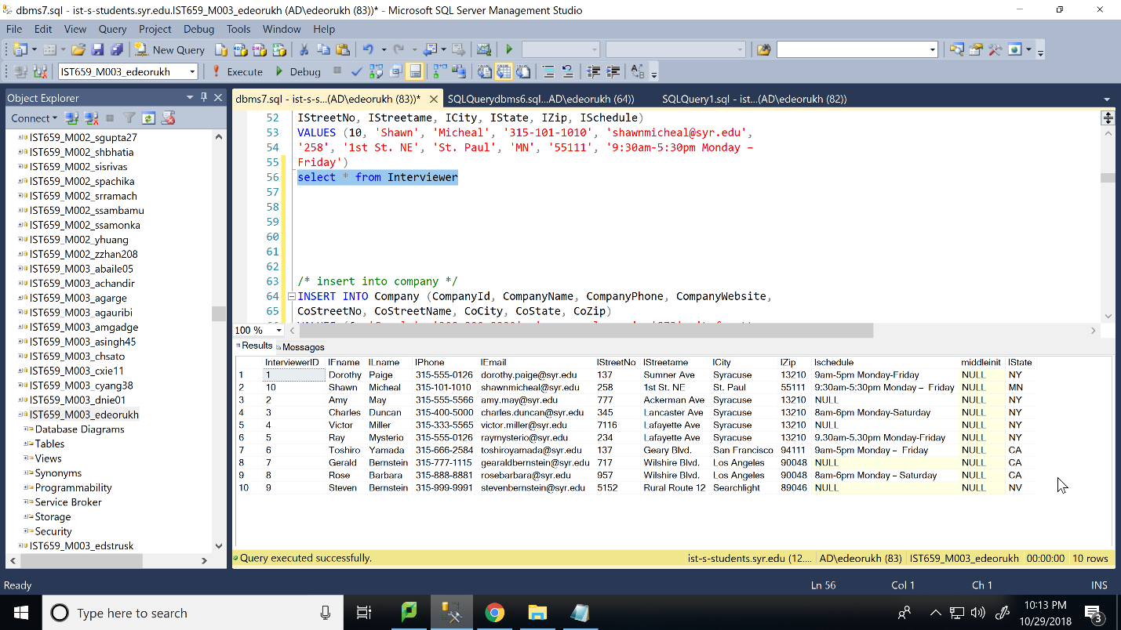

/* insert into company */

INSERT INTO Company (CompanyId, CompanyName, CompanyPhone, CompanyWebsite,

CoStreetNo, CoStreetName, CoCity, CoState, CoZip)

VALUES (6, 'Google', '300-000-0000', 'www.google.com', '873', 'Lafayette

Rd', 'Mountain View', 'CA', '13205')

INSERT INTO Company (CompanyId, CompanyName, CompanyPhone, CompanyWebsite,

CoStreetNo, CoStreetName, CoCity, CoState, CoZip)

VALUES (7, 'SAS', '311-111-1111', 'www.SAS.com', '456', 'Summer Ave',

'Cary', 'NC', '81000')

INSERT INTO Company (CompanyId, CompanyName, CompanyPhone, CompanyWebsite,

CoStreetNo, CoStreetName, CoCity, CoState, CoZip)

VALUES (8, 'NetApp', '315-333-4787', 'www.netapp.com', '791', 'Maryland

Ave', 'Sunnyvale', 'CA', '13801')

INSERT INTO Company (CompanyId, CompanyName, CompanyPhone, CompanyWebsite,

CoStreetNo, CoStreetName, CoCity, CoState, CoZip)

VALUES (9, 'Edward Jones', '315-444-5677', 'www.edwardjones.com', '437',

'Lanchaster Ave', 'St. Loius', 'MO', '79147')

INSERT INTO Company (CompanyId, CompanyName, CompanyPhone, CompanyWebsite,

CoStreetNo, CoStreetName, CoCity, CoState, CoZip)

VALUES (10, 'Qualcomm', '315-479-5182', 'www.qualcomm.com', '825',

'Ackerman Street', 'Weston', 'FL', '45071')

select * from Company

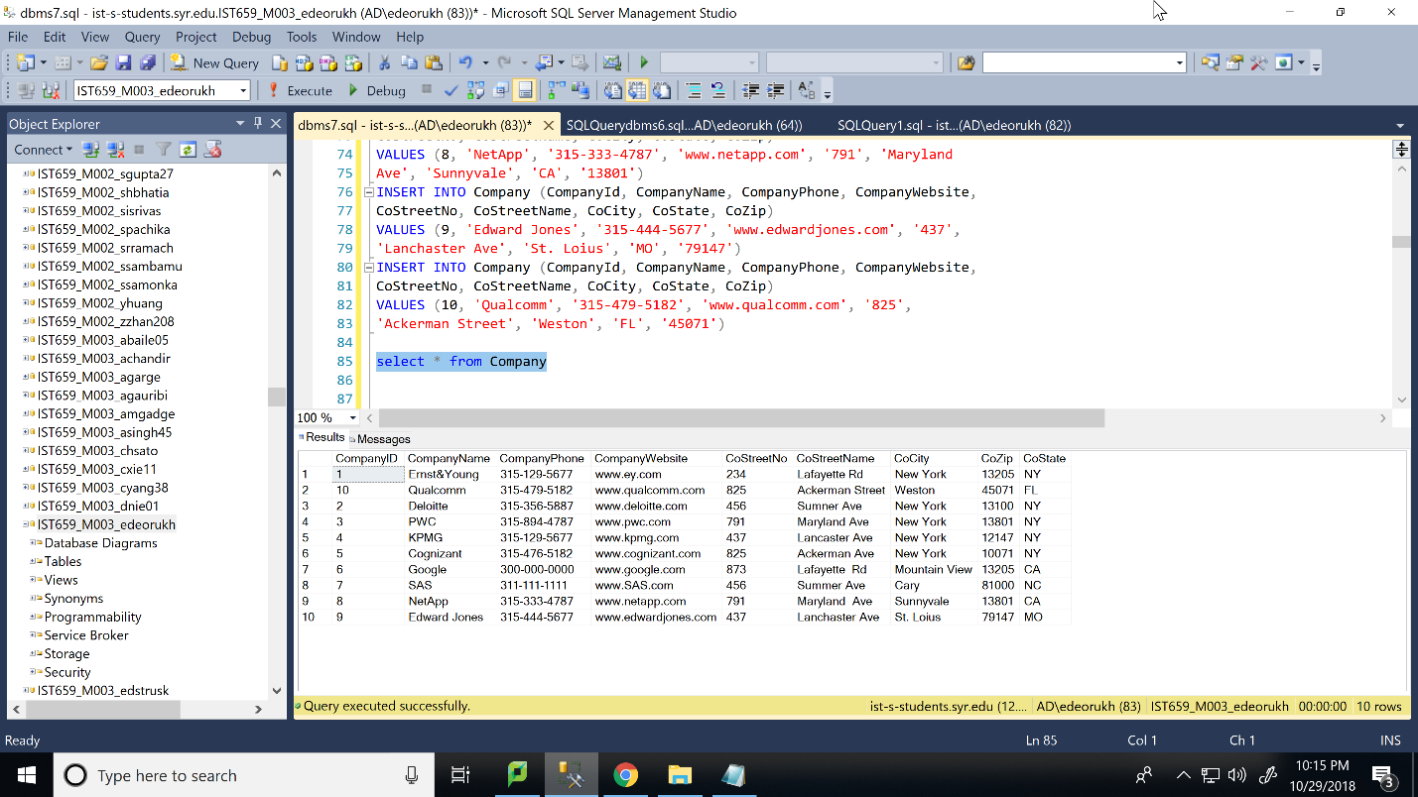

/* insert into position */

INSERT INTO Position (PositionId, PositionName, PositionLevel,

PositionAvailable, CompanyId)

VALUES (3, 'Database Analyst', 'Executive', 'yes', '2')

INSERT INTO Position (PositionId, PositionName, PositionLevel,

PositionAvailable, CompanyId)

VALUES (4, 'Risk Manager', 'Executive', 'no', '3')

INSERT INTO Position (PositionId, PositionName, PositionLevel,

PositionAvailable, CompanyId)

VALUES (6, 'Software Developer', 'Entry', 'yes', '6')

INSERT INTO Position (PositionId, PositionName, PositionLevel,

PositionAvailable, CompanyId)

VALUES (7, 'Business Analyst', 'Entry', 'yes', '6')

INSERT INTO Position (PositionId, PositionName, PositionLevel,

PositionAvailable, CompanyId)

VALUES (8, 'Database Administrator', 'Executive', 'yes', '7')

INSERT INTO Position (PositionId, PositionName, PositionLevel,

PositionAvailable, CompanyId)

VALUES (9, 'Technical Manager', 'Executive', 'no', '8')

INSERT INTO Position (PositionId, PositionName, PositionLevel,

PositionAvailable, CompanyId)

VALUES (10, 'Advisory Associate', 'Staff', 'yes', '9')

INSERT INTO Position (PositionId, PositionName, PositionLevel,

PositionAvailable, CompanyId)

VALUES (11, 'Project Manager', 'Entry', 'no', '10')

INSERT INTO Position (PositionId, PositionName, PositionLevel,

PositionAvailable, CompanyId)

VALUES (12, 'Project Manager', 'Managerial', 'no', '10')

select * from Position

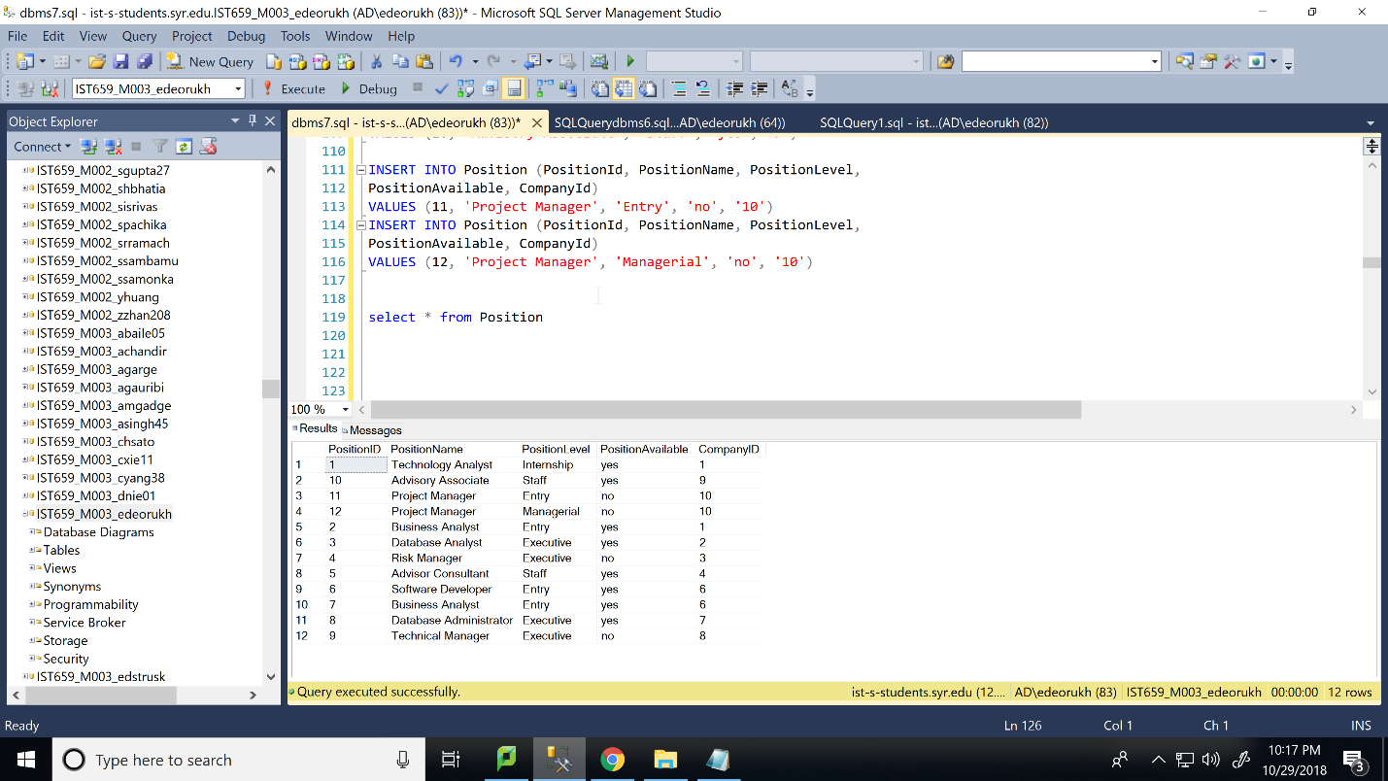

/* insert into interview */

INSERT INTO Interview(InterviewId, RoundNumber, InterviewDate, CandidateId,

InterviewerId, PositionId)

VALUES (6,2,'2013-05-07 00:00:00.000',6,7,6);

INSERT INTO Interview(InterviewId, RoundNumber, InterviewDate, CandidateId,

InterviewerId, PositionId)

VALUES (7,1,'2013-04-28 00:00:00.000',7,7,7);

INSERT INTO Interview(InterviewId, RoundNumber, InterviewDate, CandidateId,

InterviewerId, PositionId)

VALUES (8,3,'2013-10-07 00:00:00.000',8,8,8);

INSERT INTO Interview(InterviewId, RoundNumber, InterviewDate, CandidateId,

InterviewerId, PositionId)

VALUES (9,5,'2013-10-17 00:00:00.000',9,9,9);

INSERT INTO Interview(InterviewId, RoundNumber, InterviewDate, CandidateId,

InterviewerId, PositionId)

VALUES (10,2,'2013-06-07 00:00:00.000',6,7,12);

INSERT INTO Interview(InterviewId, RoundNumber, InterviewDate, CandidateId,

InterviewerId, PositionId)

VALUES (11,1,'2013-08-08 00:00:00.000',7,7,11);

INSERT INTO Interview(InterviewId, RoundNumber, InterviewDate, CandidateId,

InterviewerId, PositionId)

VALUES (12,3,'2013-10-07 00:00:00.000',10,8,5);

INSERT INTO Interview(InterviewId, RoundNumber, InterviewDate, CandidateId,

InterviewerId, PositionId)

VALUES (13,5,'2013-8-18 00:00:00.000',10,9,9);

INSERT INTO Interview(InterviewId, RoundNumber, InterviewDate, CandidateId,

InterviewerId, PositionId)

VALUES (14,2,'2013-06-28 00:00:00.000',5,7,6);

INSERT INTO Interview(InterviewId, RoundNumber, InterviewDate, CandidateId,

InterviewerId, PositionId)

VALUES (15,1,'2013-07-27 00:00:00.000',3,8,9);

INSERT INTO Interview(InterviewId, RoundNumber, InterviewDate, CandidateId,

InterviewerId, PositionId)

VALUES (16,3,'2013-01-06 00:00:00.000',6,8,12);

INSERT INTO Interview(InterviewId, RoundNumber, InterviewDate, CandidateId,

InterviewerId, PositionId)

VALUES (17,1,'2013-10-17 00:00:00.000',6,9,9);

INSERT INTO Interview(InterviewId, RoundNumber, InterviewDate, CandidateId,

InterviewerId, PositionId)

VALUES (18,2,'2013-06-07 00:00:00.000',4,7,12);

INSERT INTO Interview(InterviewId, RoundNumber, InterviewDate, CandidateId,

InterviewerId, PositionId)

VALUES (19,1,'2013-08-08 00:00:00.000',2,10,11);

INSERT INTO Interview(InterviewId, RoundNumber, InterviewDate, CandidateId,

InterviewerId, PositionId)

VALUES (20,2,'2013-10-7 00:00:00.000',10,8,5);

INSERT INTO Interview(InterviewId, RoundNumber, InterviewDate, CandidateId,

InterviewerId, PositionId)

VALUES (21,2,'2013-6-17 00:00:00.000',10,9,9);

select * from Interview

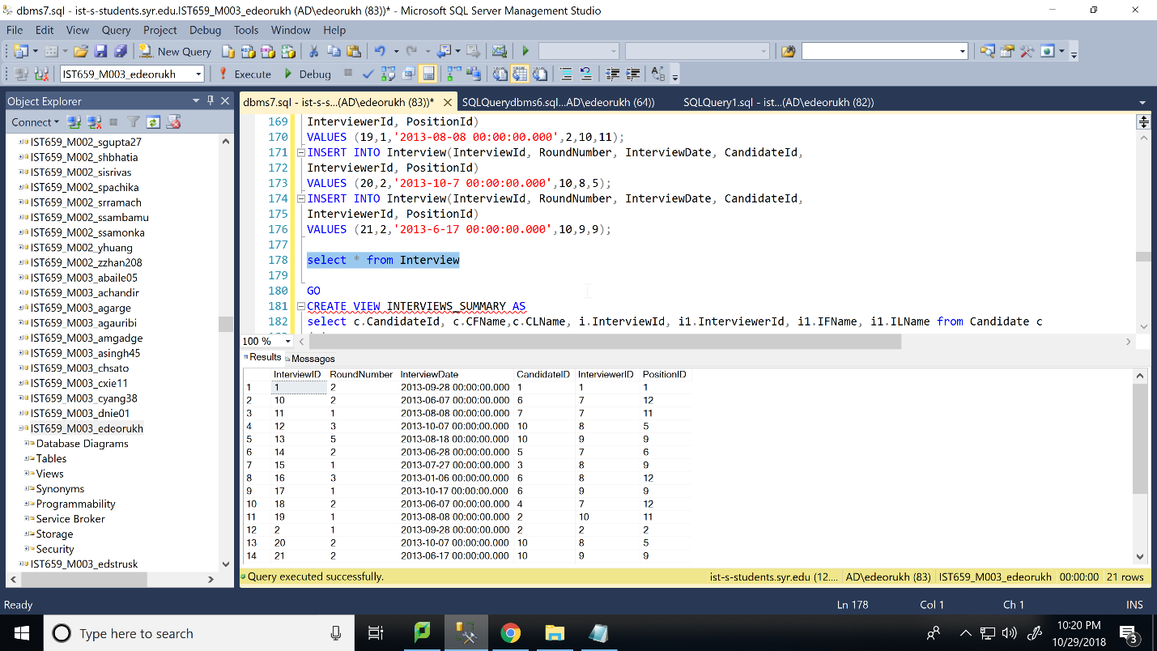

interviews_summary: for all the candidates, find their interviews and the corresponding interviewers. This view should show the candidate ID, candidate name, interview ID, interviewer ID, and interviewer name

/* GO is used to start a new query batch as CREATE VIEW statements can only be used at the beginning of query sections */

GO

CREATE VIEW INTERVIEWS_SUMMARY AS

select c.CandidateId, c.CFName,c.CLName, i.InterviewId, i1.InterviewerId, i1.IFName, i1.ILName from Candidate c

join

Interview i on c.CandidateId=i.CandidateId

join

Interviewer i1 on i.InterviewerId=i1.InterviewerId

select * from INTERVIEWS_SUMMARY

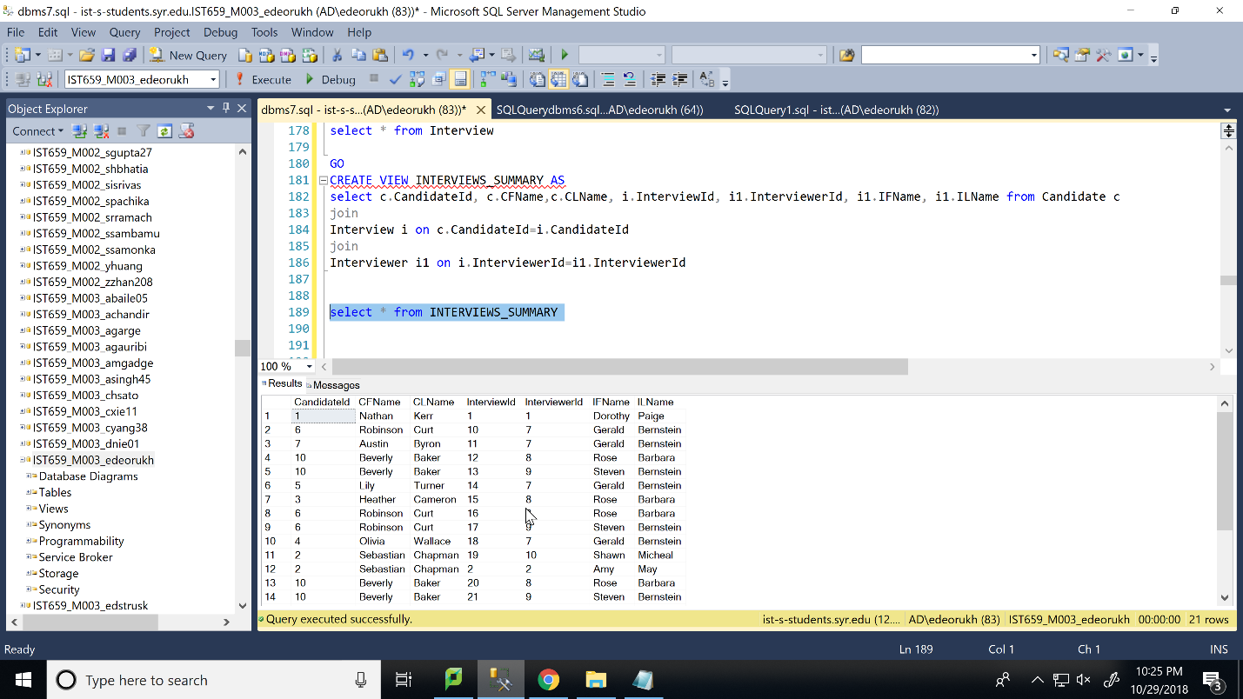

position_summary: find the total number of positions available for each company in the second half of 2013 (Jul, Aug, Sep, Oct, Nov, Dec).

GO

CREATE VIEW POSITION_SUMMARY AS

SELECT c.CompanyId, c.CompanyName, count(p.PositionId) as Number_of_Positions FROM Position p

join Interview i on p.PositionId=i.PositionId

join Company c on p.CompanyId=c.CompanyId

WHERE i.InterviewDate between '2013-07-01' and '2013-12-31'

GROUP BY c.CompanyId, c.CompanyName

select * from POSITION_SUMMARY

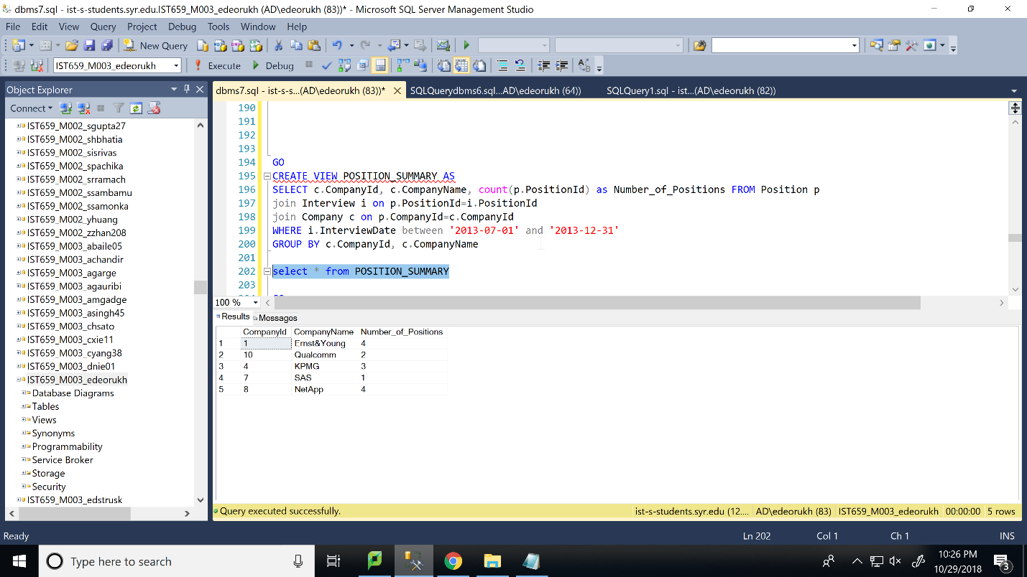

maximum_candidate_interview_summary: find the candidate who had the largest number of interviews.

GO

CREATE VIEW maximum_candidate_interview_summary as

select c.CandidateId, CFName, CLName, count(InterviewId) as Number_of_Interviews

from Candidate c

join

Interview i on c.CandidateId=i.CandidateId

group by c.CandidateId, CFName, CLName

having count(InterviewId)= (select max(abc.cnt) from (select c.CandidateId , c.CFName, c.CLName,count(InterviewId) as cnt from Interview i

join

Candidate c on i.CandidateId=c.CandidateId

group by c.CandidateId,c.CFName, c.CLName) as abc)

select * from maximum_candidate_interview_summary

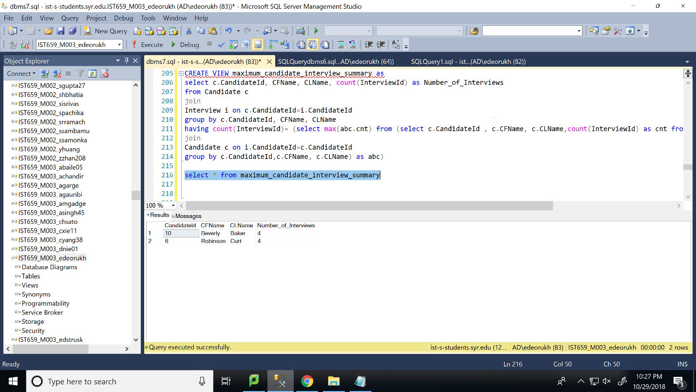

minimum_interviewer_prescription_summary: find the interviewer who had the lowest number of interviews.

go

create view minimum_interviewer_prescription_summary as

select i2.InterviewerId, i2.IFName, i2.ILName, count(InterviewId) as Number_of_Interviews

from Interviewer i2

left join

Interview i on i.InterviewerId=i2.InterviewerId

group by i2.InterviewerId, i2.IFName, i2.ILName

having count(InterviewId)= (select min(cnt) from (select count(InterviewId) as cnt from Interview i

right join

Interviewer i2 on i2.InterviewerId=i.InterviewerId

group by i2.InterviewerId) as abc)

select * from minimum_interviewer_prescription_summary

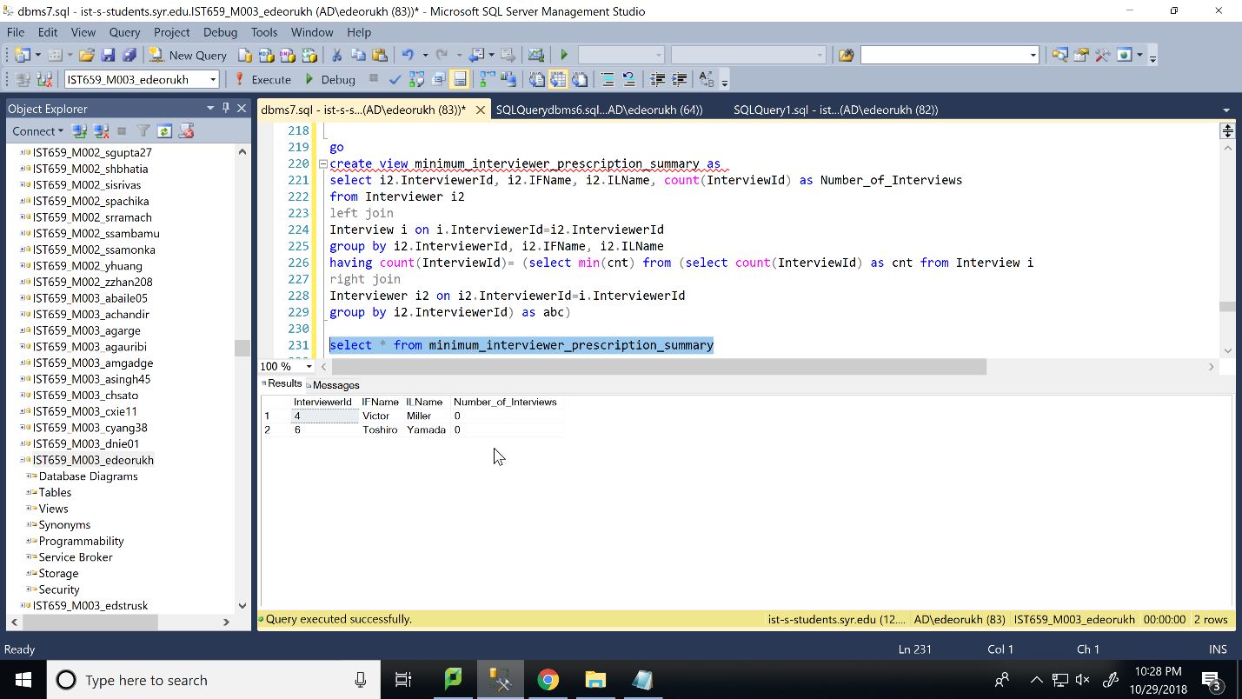

position_interview_summary: find the position for which the largest number of interviews were conducted.

go

create view position_interview_summary as

select p.PositionId, p.PositionName, count(InterviewId) as Number_of_Interviews

from Position p

join

Interview i on p.PositionId=i.PositionId

group by p.PositionId, p.PositionName

having count(InterviewId)= (select max(abc.cnt) from (select count(InterviewId) as cnt from Interview i

join

Position p on p.PositionId=i.PositionId

group by p.PositionId) as abc)

select * from position_interview_summary

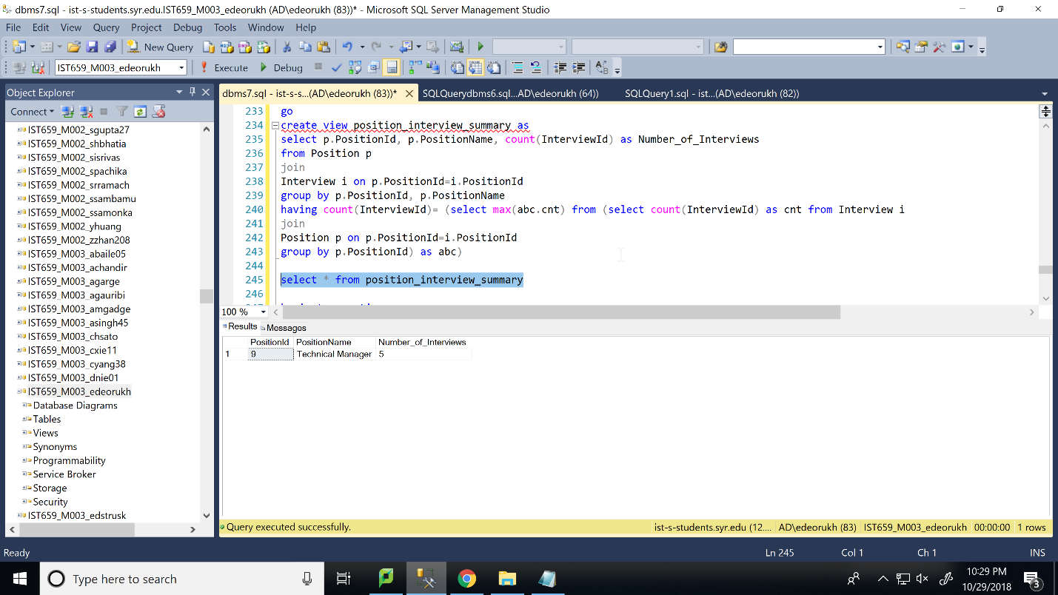

Create a new interview for a new candidate.

New rows should be inserted into the tables Candidate, Interview, and Position.

Step 1: create a new candidate record whose first name is “Shah”, last name is “Kantilal”, and phone number is “315-525-2552”. His address is “193 Lancaster Ave, Syracuse, New York, 13210”. Candidate experience is in “Database and Development” and Relevant Experience is in “Database Administration”. He was interviewed on “2013-11-08 00:00:00.000” for his 1st round of interview for 9 “Database Developer” position at Google. Position level is “Entry” and position is available. His interviewer was “Rose Barbara”.

Step 2: display records from Candidate, Interview, and Position table.

Step 3: ROLLBACK transaction.

Step 4: display records from Candidate, Interview, and Position table.

begin transaction

/* transaction */

/* candidate */

--Candidate

insert into Candidate (CandidateId,CFName,CLName,CPhone,CEmail,CStreetno,CStreetName,CCity,CState,CZip,CExperience,CRelevantExp)

values (11,'Shah','Kantilal','315-525-2552','kshah@gmail.com',193, 'Lancaster Ave', 'Syracuse','NY', 13210, 'Database, Development','Database Administration');

--Position

--PositionId varchar(20), PositionName , PositionLevel , PositionAvailable , CompanyId ,

insert into Position values(13,'Database Developer','Entry','yes',6);

--Interview Table

--InterviewId varchar(20),RoundNumber InterviewDate , CandidateId , InterviewerId ,PositionId ,

insert into Interview values(22,1,'2013-11-08 00:00:00.000',11,8,13);

select * from Candidate

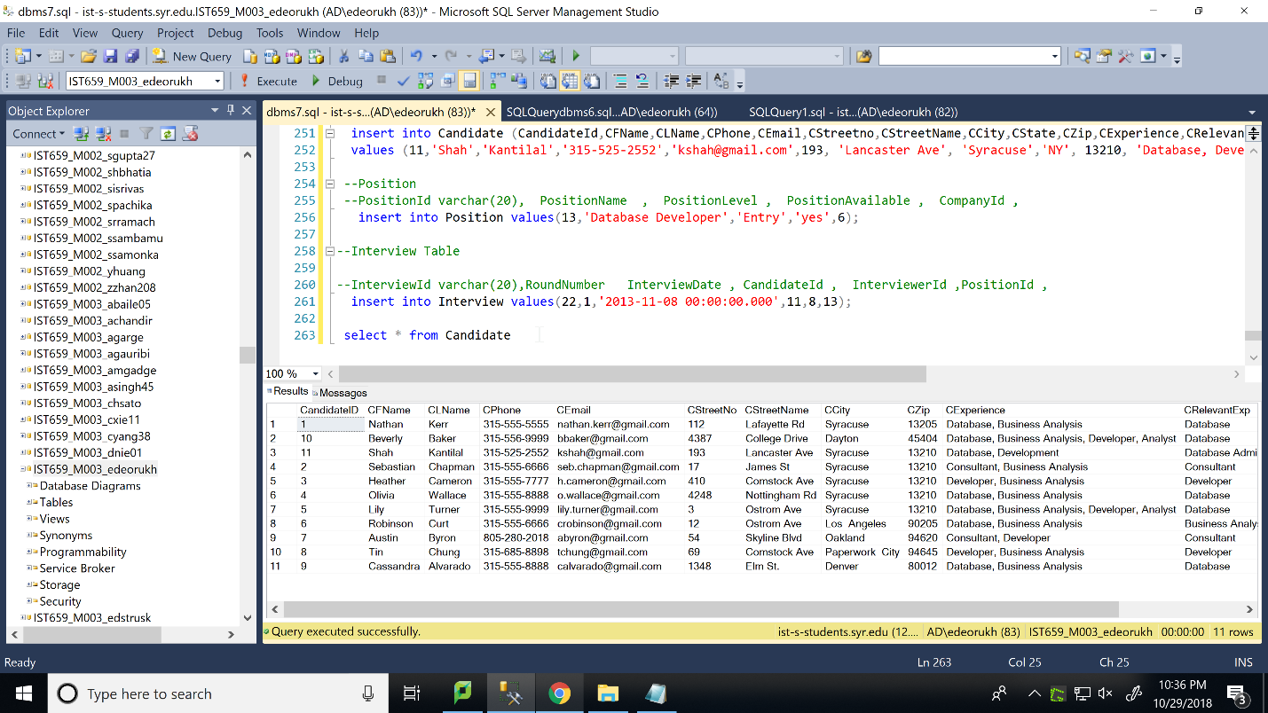

select * from Position

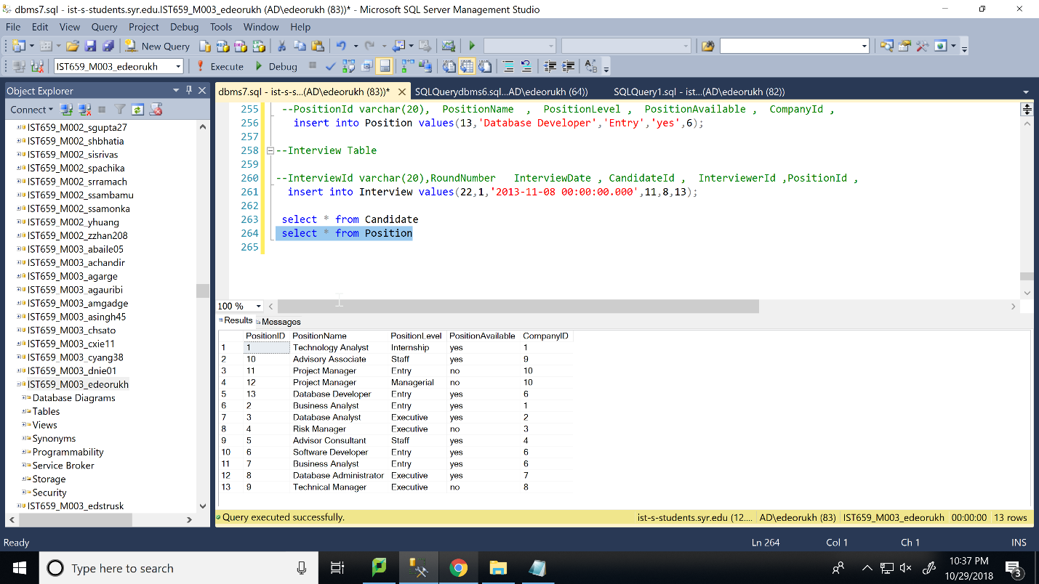

select * from Interview

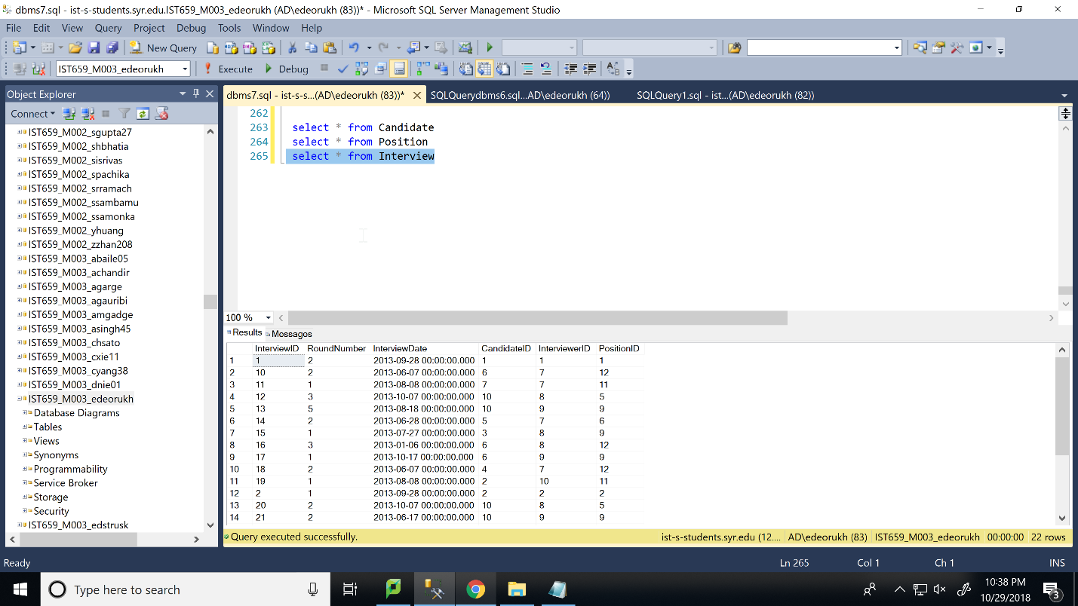

rollback

select * from Candidate

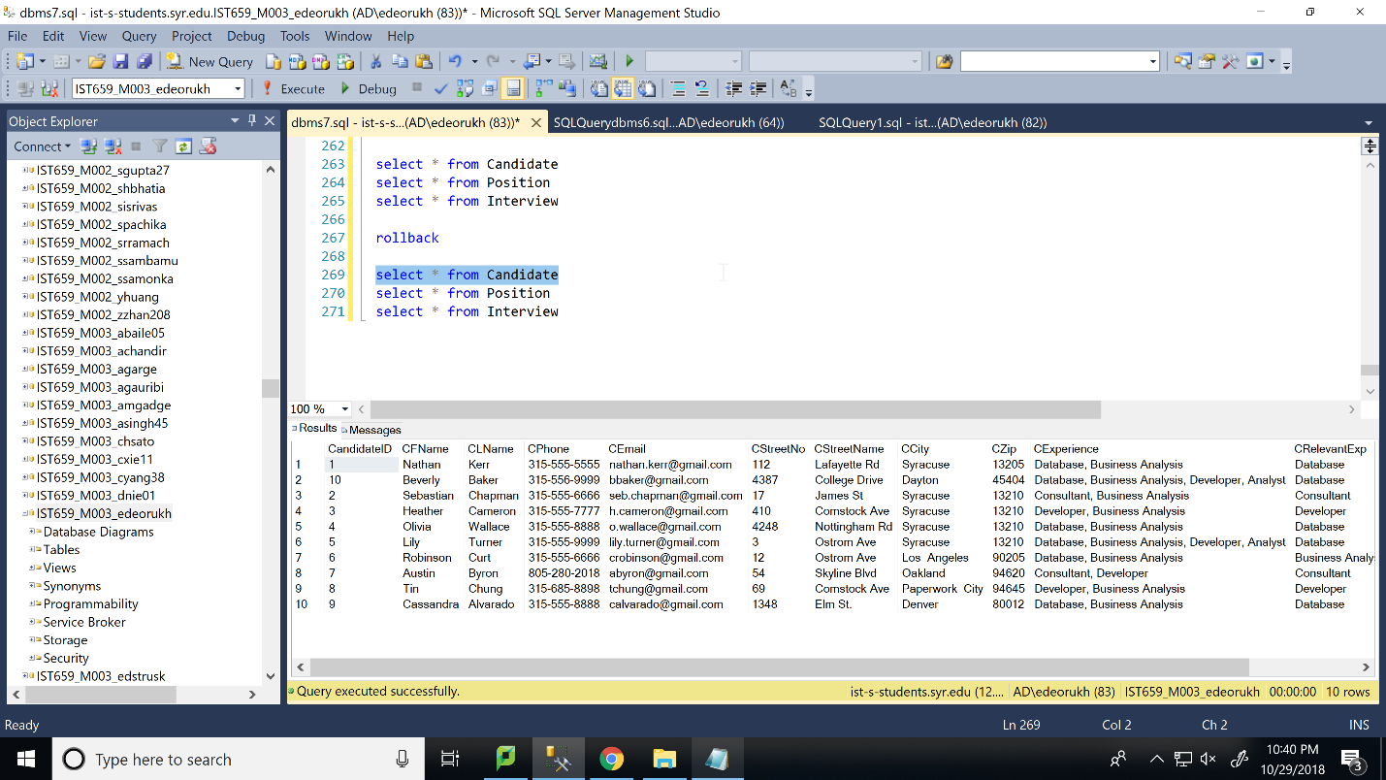

select * from Position

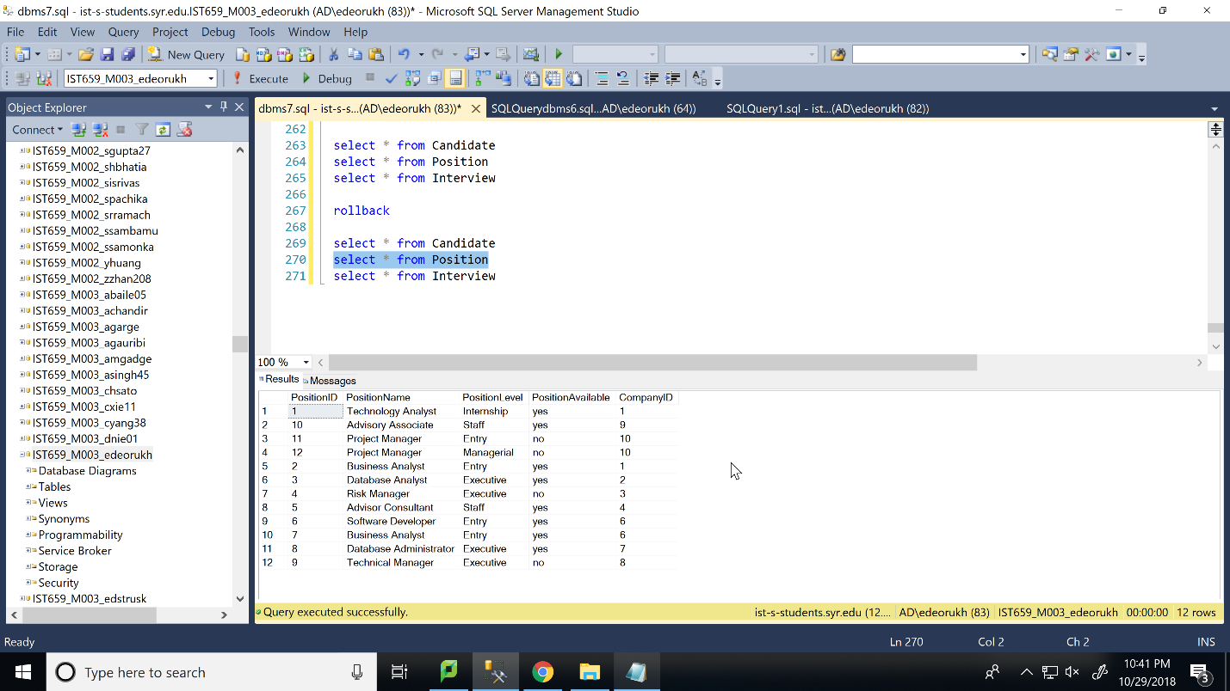

select * from Interview

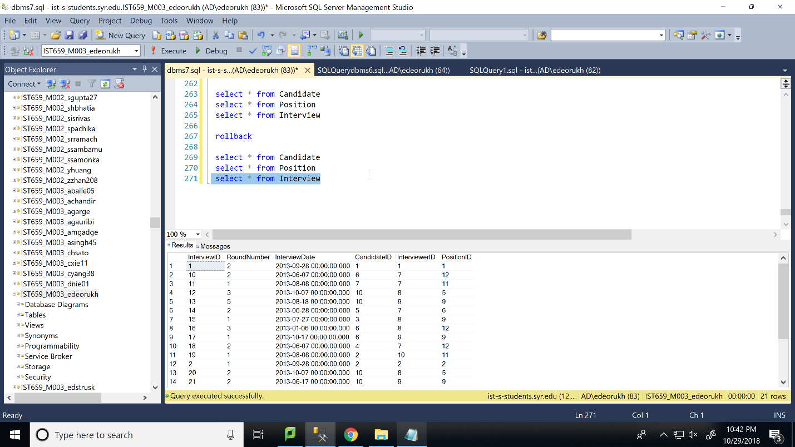

Add a new position for a company. New rows should be inserted into the tables Company, Position and Interview.

Step 1: create a new record for the company “Apple”. The company has a website URL www.apple.com and company phone is “400-000-1212”. Company Headquarters’ address is “1 Infinite Loop Cupertino, CA 95014”. The position they are hiring for is “Program Analyst” which is a “Staff” position. The 1st round of interviews were conducted for 3 candidates on “2013-11-01 00:00:00.000”. The 3 candidates were “Sebastian Chapman”, “Lily Turner” and “Tin Chung”. Also the interviewer was “Shawn Micheal” Step 2: display records from Company, Position and Interview table.

Step 3: COMMIT transaction.

Step 4: display records from Company, Position and Interview table.

Begin Transaction

--Company

insert into Company(CompanyId, CompanyName, CompanyPhone, Companywebsite, CoStreetNo, CoStreetName,CoCity, CoState, CoZip)

values (11, 'Apple', '400-000-1212', 'www.apple.com', 1, 'Infinite Loop Cupertino', 'California', 'CA', 95014);

--Position

--PositionId varchar(20), PositionName , PositionLevel , PositionAvailable , CompanyId ,

insert into Position values(13,'Program Analyst','Staff','yes',11);

--Interview Table

--InterviewId varchar(20),RoundNumber InterviewDate , CandidateId , InterviewerId ,PositionId ,

insert into Interview values(22,1,'2013-11-01 00:00:00.000',2,8,13);

insert into Interview values(23,1,'2013-11-01 00:00:00.000',5,8,13);

insert into Interview values(24,1,'2013-11-01 00:00:00.000',8,8,13);

select * from Company

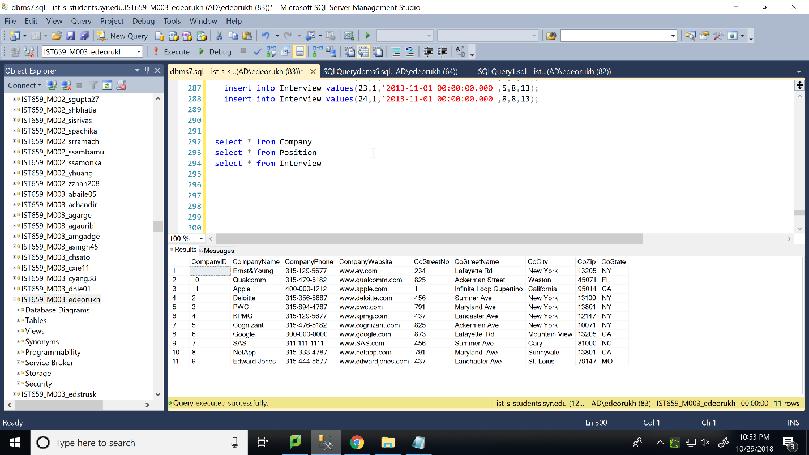

select * from Position

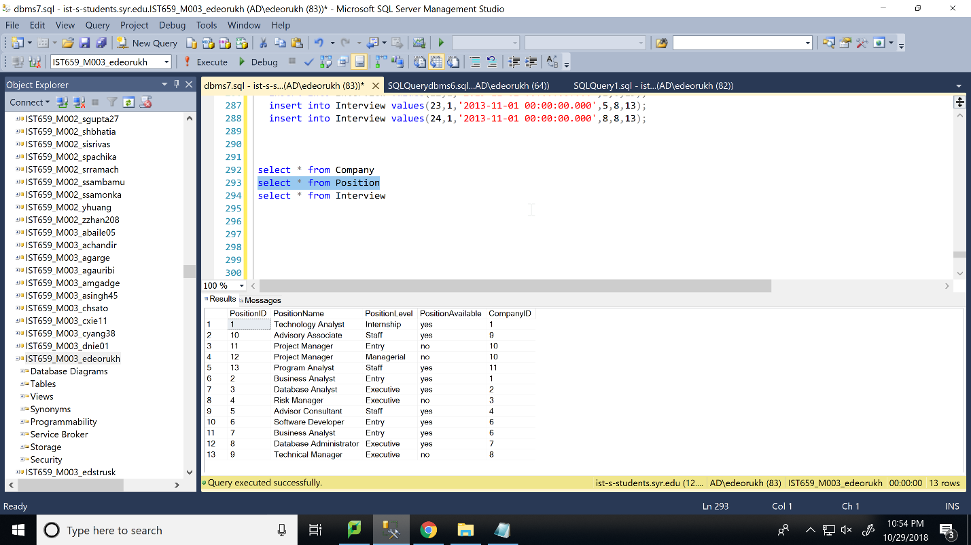

select * from Interview

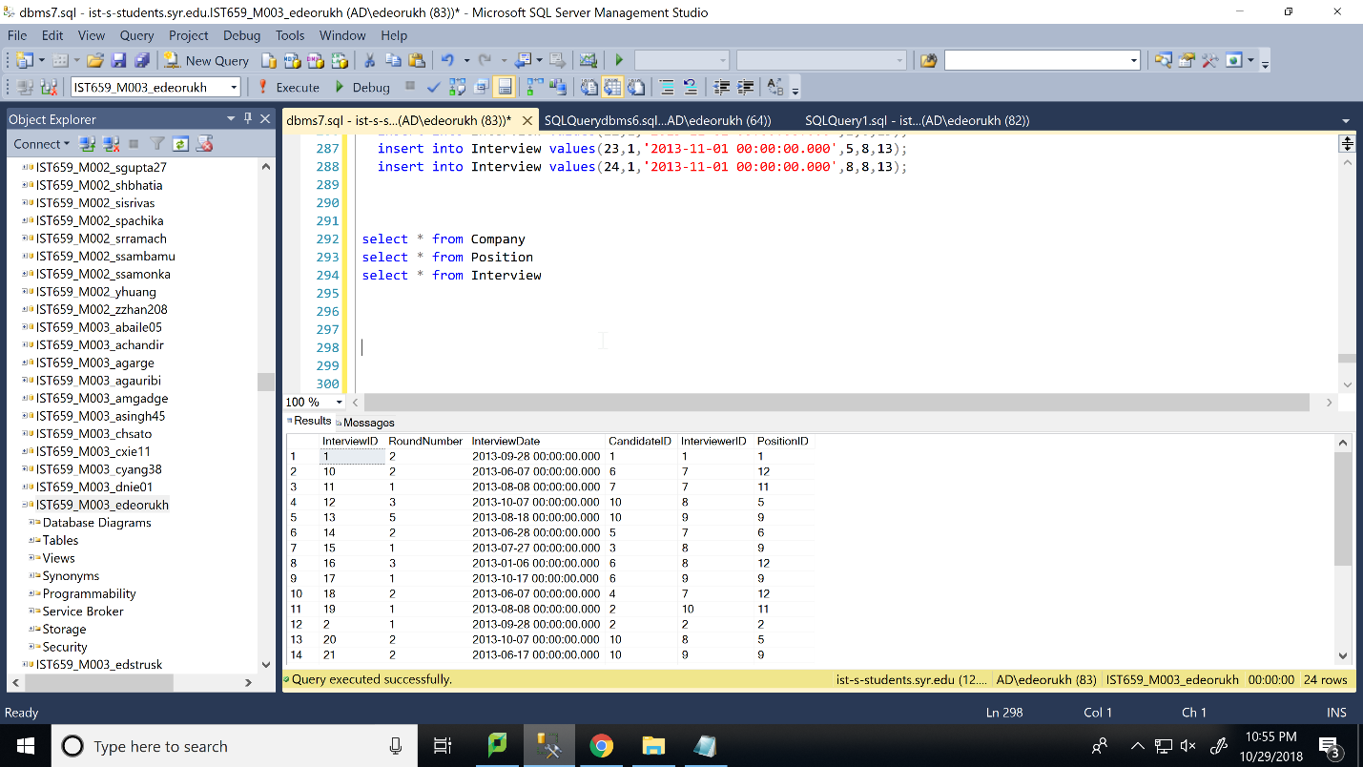

commit

select * from Company

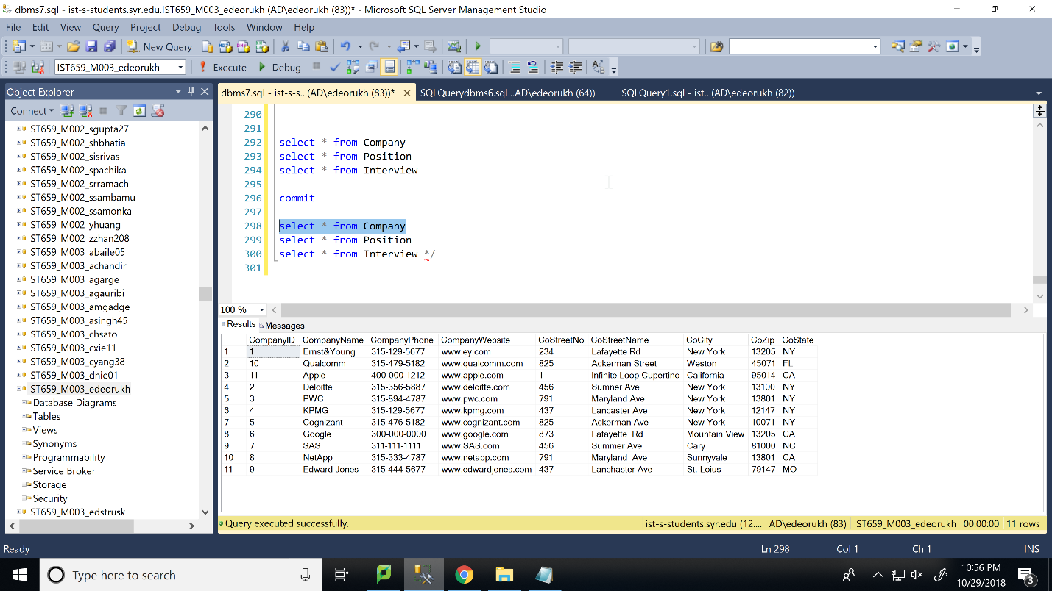

select * from Position

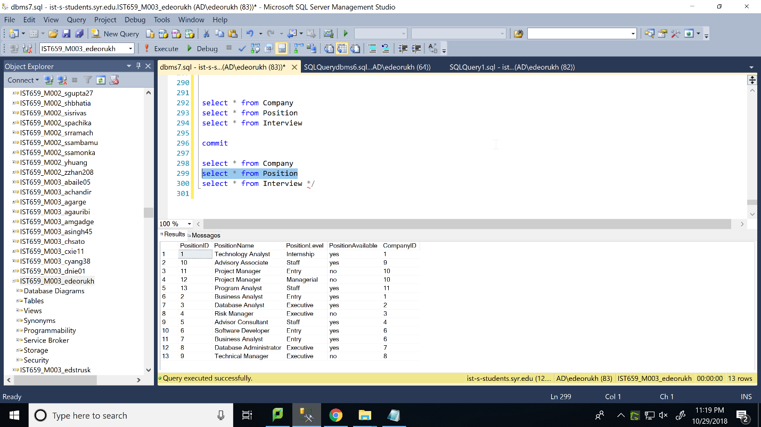

select * from Interview

